|  |  |
| --- | --- |
| Date | 21 November 2022 |
| Team ID | PNT2022TMID15090 |
| Project Name | Hazardous Area Monitoring for industrial Plant powered by IoT |

Create HTTP Requests To Communicate With Mobile App

Create an HTTP API for communicating with Mobile applications.

And also use Cloudant DB nodes to store the received sensor data in the Cloudant DB

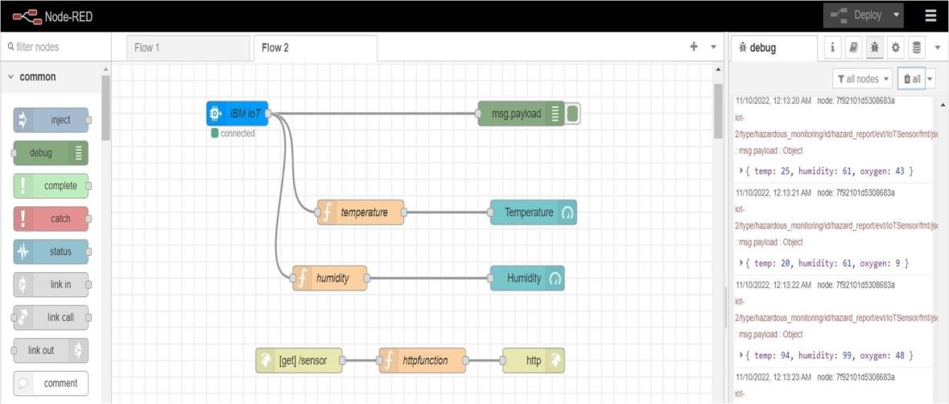

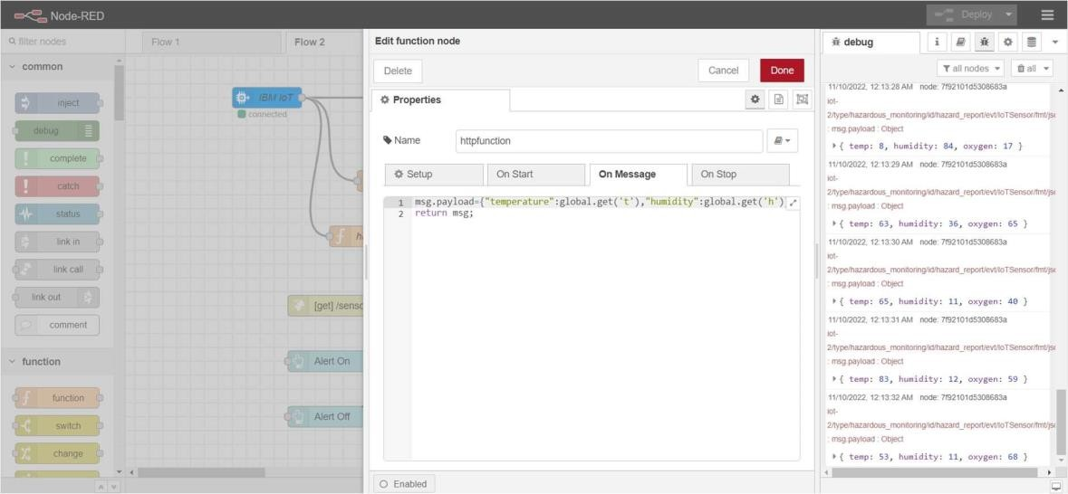

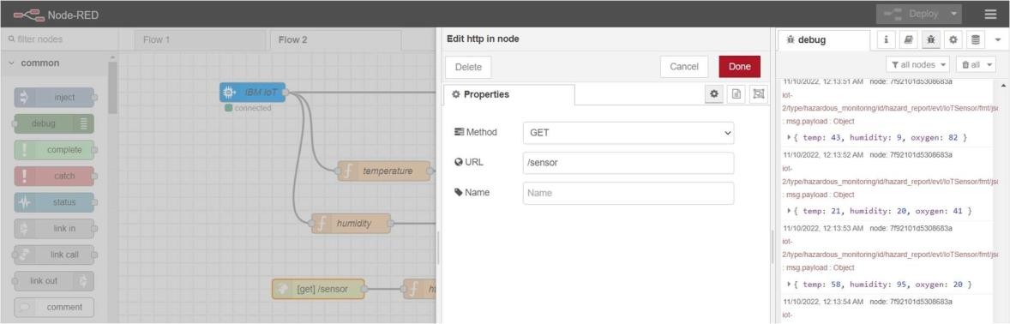

Node Red Dashboard

